# App Designer

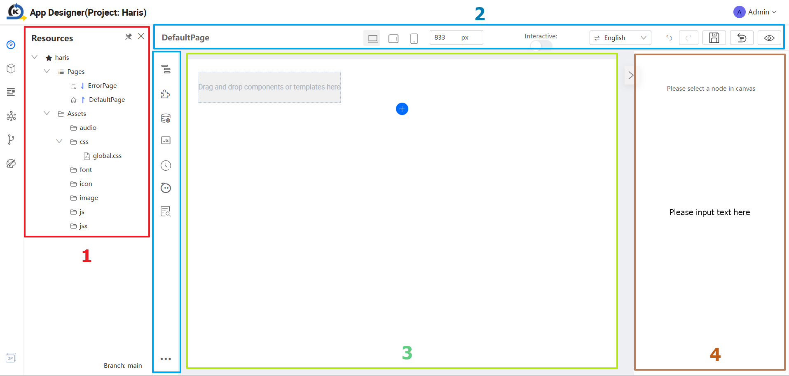

## **Resource panel**: The Resource Panel is where you manage and access various pages related to your application.

## **Plugin Panel**: The Plugin Panel is a section that displays and allows you to manage the plugins or extensions integrated into the platform or software. Plugins enhance functionality or provide additional features.

### Component Tree

The Component Tree is a hierarchical view that represents the structure of the components within your project. It visually organizes and displays the relationships between different elements.

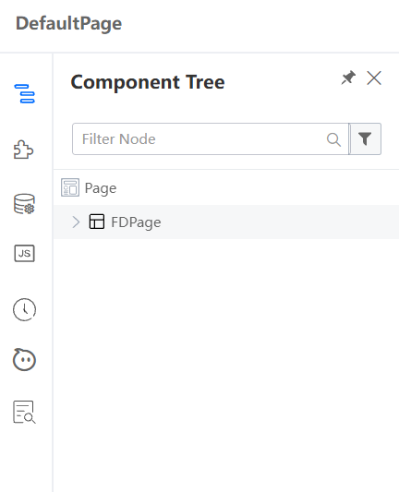

### Components Library

The Components Library is a collection of pre-built components that you can easily drag and drop into your application.

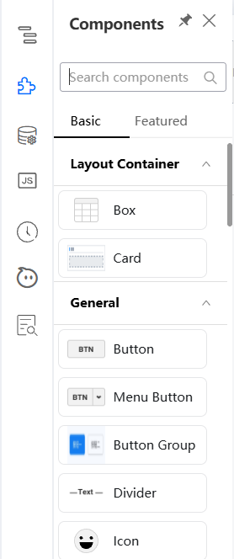

### Datasource

Datasource refers to the data connection or repository from which your application retrieves information such as API.

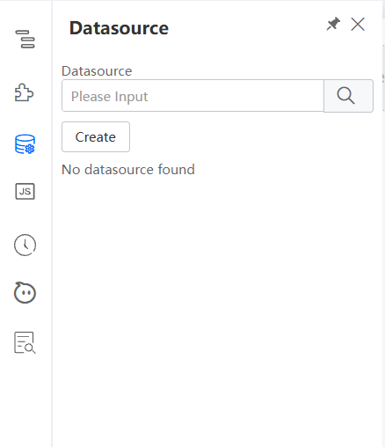

### Source Code Panel

The Source Code Panel is where you can view and edit the underlying source code of your project. It provides direct access to the code for users who prefer or need to work at the code level.

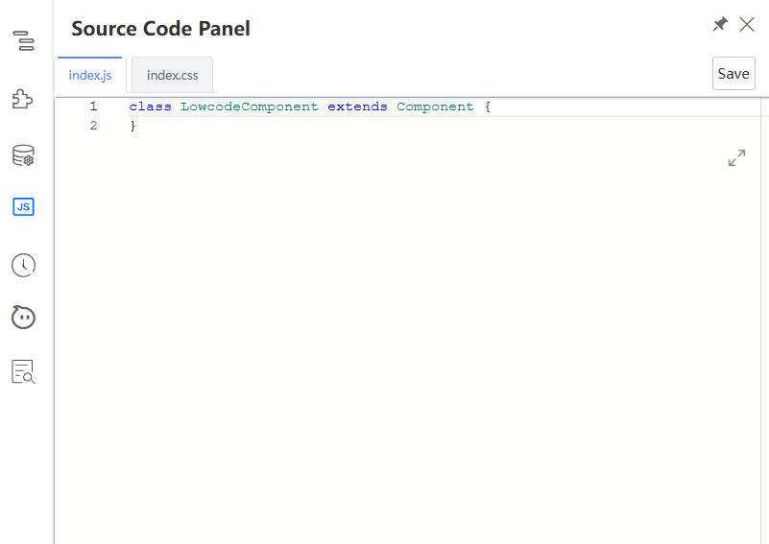

### Revision

The Revision feature allows you to track changes made to your project over time. It provides a version history, making it easy to revert to a previous state if needed.

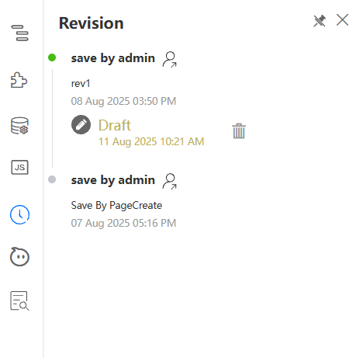

### Comment

Comments are annotations or notes that you can add to your application. They provide explanations, insights, or instructions for yourself or collaborators.

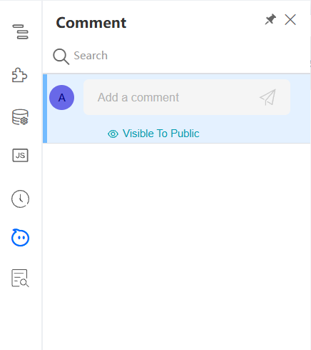

### Page Scan

Page Scan is a tool that analyses and checks your project or application for potential issues, errors, or improvements. It helps ensure the quality and performance of your work.

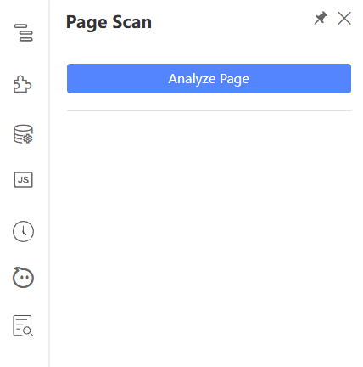

### Libraries

Libraries are collections of reusable code or resources that can be imported into your project. They save time and effort by providing pre-built functionalities.

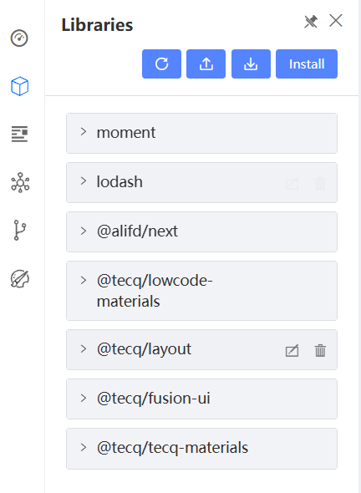

### Profiles

Profiles allow users to redirect traffic to different resources, enhancing local development. This feature enables smooth development of APIs in a local environment while still interacting with KAIZEN resources, improving the overall development experience.

Essentially, users can use profiles to configure and connect to different environments, allowing you to easily access the APIs there from your frontend pages in the app designer. All these can be done without having to build and run your entire frontend application locally. Note that you can only connect to 1 profile at a time.

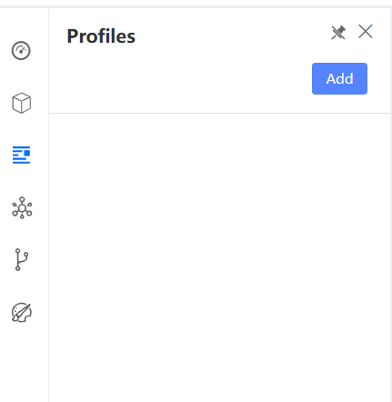

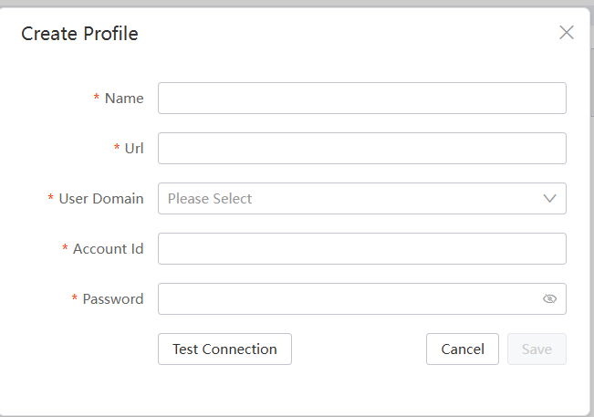

### Services

### Git

On the KAIZEN App Designer, click on the Git button and click Connect to connect to Git.

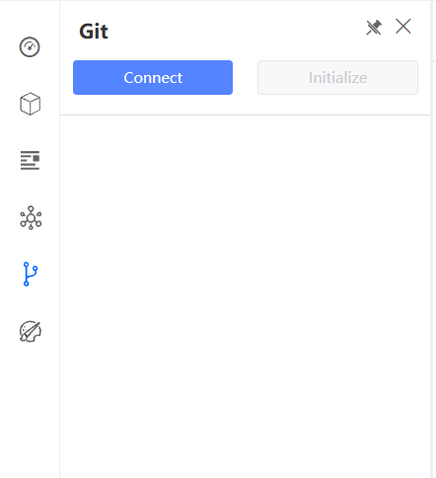

### Theme

Theme allow users to select and apply themes to user applications.

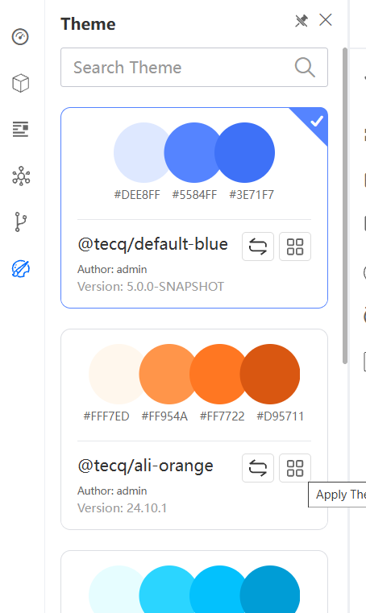

### Language

This feature allows users to switch between different languages seamlessly, making the application accessible to a wider, global audience.

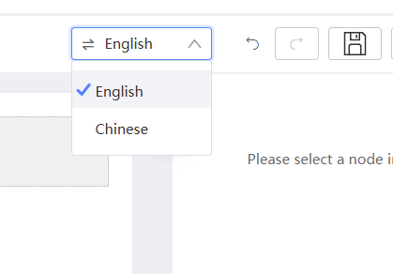

### Schema

Schema defines the structure and organization of your data in JSON format. It outlines the relationships, constraints, and rules governing how data is stored and accessed.

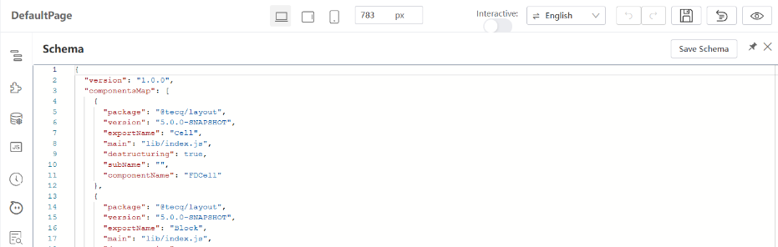

### Responsive layout

Responsive Layout refers to the design approach that ensures your project adapts and looks good on various devices and screen sizes, providing a consistent user experience.



### Save Draft

* The Save Draft feature allows you to save your project progress in KAIZEN app designer if you wish to save the progress without finalizing the design.
* After any changes then click save draft button, click on the revision button and we can see that a draft has been saved in revision.
* Kaizen also has an auto-save mechanism every 15 minutes in the app designer. This period can be configured at system level depending on project needs.

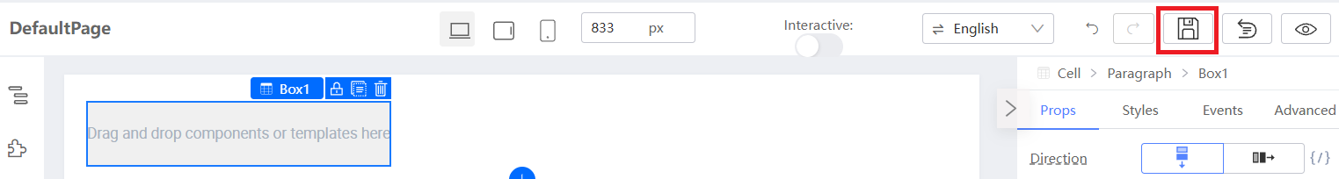

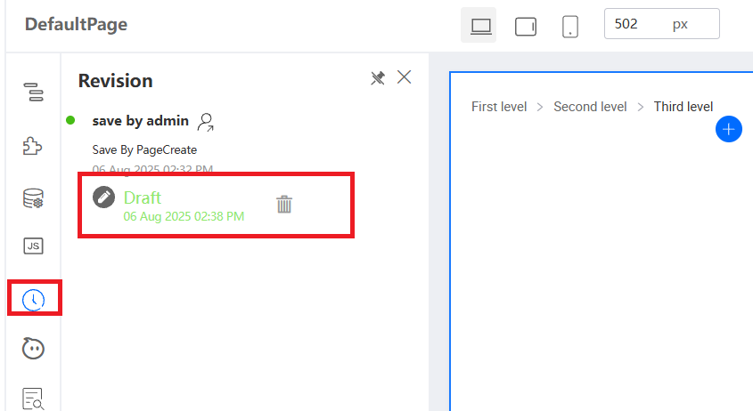

* When close the KAIZEN App Designer and re-open the same application again, or navigate to another page and back to this same page, it will prompt open draft revision dialog if there is a draft saved on this page.

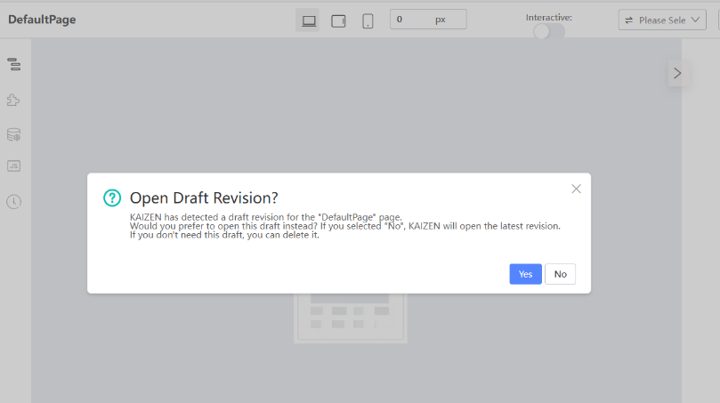

* Click “Yes” if you wish to open the draft saved previously. It will open the page that we saved previously in draft.
* Click “No” if you wish to open the page from the latest revision.
* Note that when you save a draft, it is stored privately in your account’s application. This means that only you have access to it, and other users cannot view or edit your saved work.
* However, if you wish to save your changes and be visible to other users, you must **publish** the page.

### Publish Page

The Publish Page feature allows you to save your finalized page in KAIZEN app designer. Once published, your page becomes visible to other users. This means that team members, collaborators, or any designated user can view and interact with your content. It transforms your private draft into a shared resource.

* Let try to edit the page
* Click on the revision button, and you can see a new revision history is updated.



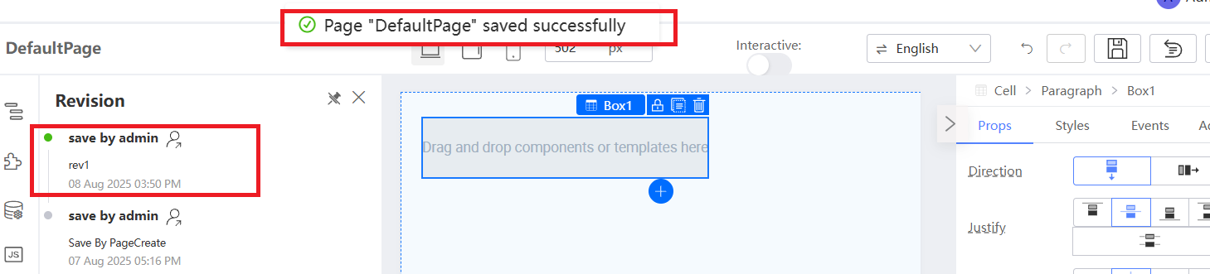

* Now, close the KAIZEN App Designer and re-open the same application again. It will not prompt open draft revision dialog anymore as currently there is no draft saved in the application.
* When you publish the page, it will be visible to other users in the project. This means that other users can view or continue editing your work which has been published. The revision history from another account will be the same.

### Reset Page

The Reset feature will reset your page to an empty page, allowing the user to remove all the components added in the page with a reset button.   
Note that you will **not** be able to undo this change!

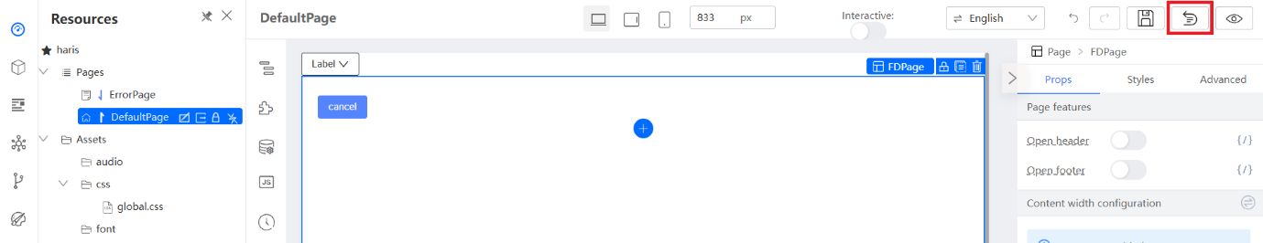

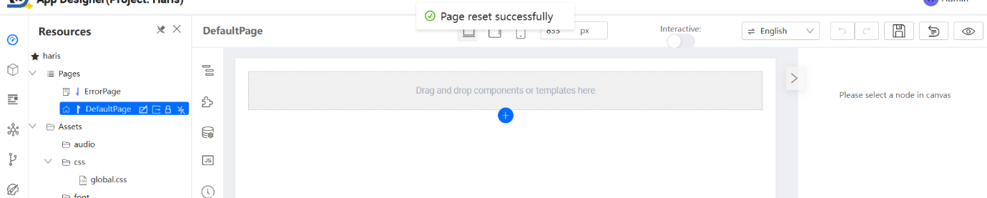

### Preview

The Preview Page feature allows you to see how your page will look and function. The preview feature provides a real-time view of your page, showing exactly how it will appear to end-users. Besides, you also can test the functionality of your page, including buttons, links, forms, and other interactive elements. This helps you identify and fix any issues before making the page live.

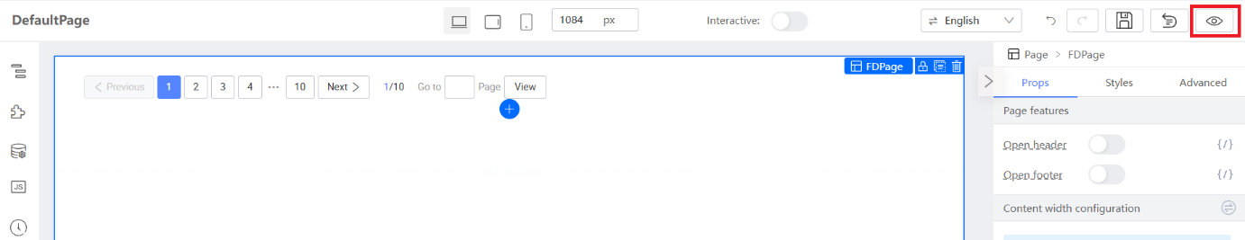

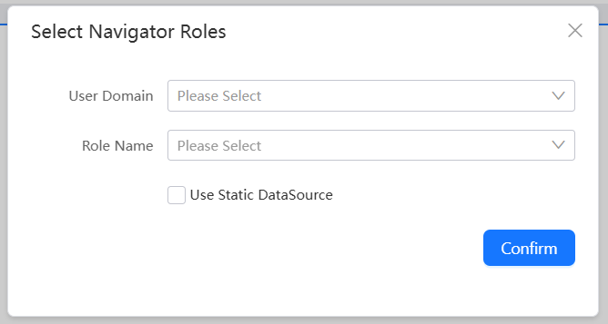

Note that once you click on the preview button, you will be prompted to **select the navigator roles** in which you want to preview. This functionality aids in the configuration of necessary privileges and roles during the design stage to restrict the **access of pages** through the **navigator menus** in the application. However, in this training tutorial, we will not need to indicate or choose the user domain or role name. Simply click on ‘Confirm’ to skip this selection and your application preview without any access restrictions.

### Page Lock

The Page Lock feature is a mechanism designed to control and manage collaborative editing in a shared project environment.This feature ensures that critical or in-progress work on a page is not unintentionally modified or overwritten by others, maintaining the integrity of the content. When a page is locked, it becomes restricted for other users. This means no other users can make significant changes and publish the page until it has been unlocked by either the user who locked the page initially or the project manager.

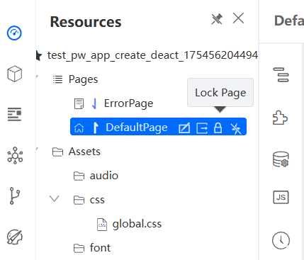

## **Canvas**

The Canvas is the visual workspace where you design and arrange the elements of your project. It is the area where you create and build.

* **Component operation**: Component Operation involves managing and manipulating individual elements or components within your project, such as copying, locking, or deleting them.

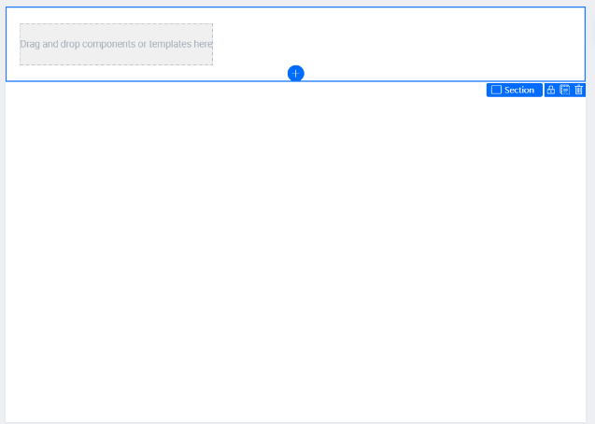

## **Setter Plugin**

A Setter Plugin is a tool or extension that allows you to configure or set specific properties or attributes of components within your project.

